Molecular and Genetic studies of Two Bread Wheat Crosses Using SSR Markers and a Six-Parameter Model Analysis
Abdelgani, Asmaa Mohamed¹, Bekhit, Makhlouf ², El-Garhy, Hoda A. S ², Gad, Khaled Ibrahim¹
¹Field Crops Research Institute, Agricultural Research Center
² Genetics and Genetic Engineering Department, Faculty of Agriculture, Benha University
Corresponding author: asmaaalagamy4@gmail.com

Abstract
This study was conducted over three consecutive growing seasons (2020/2021, 2021/2022, and 2022/2023) at Sakha Agricultural Research Station, Kafrelsheikh governorate, Egypt, to determine the genetic factors controlling the inheritance of yield and its components for two bread wheat crosses: Shandaweel 1 × Yr 8 and Shandaweel 1 × Yr 15. Inheritance of yield and yield-contributing traits was investigated using generation mean analysis with data from six populations across parents, F₁, F₂, and backcross generations, using a six-parameter model. The data revealed significant additive gene effects for plant height and 1000-kernel weight in both crosses, suggesting pedigree selection could efficiently improve these traits. Dominance gene effects were less significant in the first cross; suggesting early selection should focus on these traits. In the second cross, dominance effects were highly significant for heading date, number of grains per spike, 1000-kernel weight, and grain yield. High positive heterosis was observed for plant height and grain yield in both crosses, with significant positive inbreeding depression values for all studied traits. Broad-sense heritability values were moderate to high for all traits, indicating the significant influence of both additive and non-additive effects. High broad-sense heritability suggests more effective selection in late segregating generations. High genetic advance was associated with high narrow-sense heritability for grain yield and number of spikes per plant in the second cross.

Keywords: Wheat, Six population, heterosis, gene action, heatmap

Introduction

Wheat (Triticum aestivum L.) stands as one of the most important cereal crops worldwide, acting as a primary source of calories and protein for billions of people (Khalid et al., 2023). In Egypt, its significance is even more pronounced, as wheat serves as the backbone of the national diet (Abdalla et al., 2023). Despite its critical role, Egypt faces a substantial gap between wheat production and consumption. Annually, Egypt consumes over 20 million metric tons of wheat, with local production contributing only 8 to 9 million metric tons, making Egypt the largest wheat importer globally (USDA, 2024). This reliance highlights the pressing need for continuous improvement wheat production to meet the growing demand and ensure food security.
The gap between wheat production and consumption is further widened by the rising population and the negative impacts of climate change. Wheat yield is significantly affected by both biotic and abiotic stresses, with yellow rust, caused by Puccinia striiformis f. sp. tritici, being the most damaging disease impacting wheat production globally. (Martínez-Moreno et al., 2022; Nsabiyera et al.,2018). This disease can result in yield losses ranging from 10% to 70%, and in cases of severe early infections, it may lead to complete crop failure (Ashmawy and Ragab, 2016; Afzal, 2007).
Given these challenges, improving wheat production and developing disease-resistant cultivars have become critical priorities. Resistance to yellow rust is the most economical and environmentally friendly approach to managing the disease and eliminating the need for chemical interventions while ensuring sustainable agricultural practices (Feng et al., 2018).
Efforts to combat yellow rust have primarily focused on identifying and utilizing resistance genes, with particular emphasis on Yr genes. To date, over 100 Yr genes have been identified in wheat, 84 of which have been assigned official nomenclature. Among these, more than 70% are classified as all-stage resistance (ASR) genes, which provide protection throughout the plant's entire lifecycle. The remaining genes are adult-plant resistance (APR) genes, which become effective in later growth stages.
These Yr resistance genes are predominantly derived from wild and common wheat species, making them invaluable for breeding programs targeting enhanced yellow rust resistance. Incorporating these genes into breeding strategies offers significant potential to develop new wheat cultivars with sustainable and effective control against yellow rust, reducing dependency on chemical interventions and safeguarding yield stability (Zhang et al., 2023).
Wheat (Triticum aestivum L.) stands as one of the most important cereal crops worldwide, acting as a primary source of calories and protein for billions of people (Khalid et al., 2023). In Egypt, its significance is even more pronounced, as wheat serves as the backbone of the national diet (Abdalla et al., 2023). Despite its critical role, Egypt faces a substantial gap between wheat production and consumption. Annually, Egypt consumes over 20 million metric tons of wheat, with local production contributing only 8 to 9 million metric tons, making Egypt the largest wheat importer globally (USDA, 2024). This reliance highlights the pressing need for continuous improvement in wheat production to meet the growing demand and ensure food security.
The gap between wheat production and consumption is further widened by the rising population and the negative impacts of climate change. Wheat yield is significantly affected by both biotic and abiotic stresses, with yellow rust, caused by Puccinia striiformis f. sp. tritici, being the most damaging disease impacting wheat production globally. (Martínez-Moreno et al., 2022; Nsabiyera et al., 2018). This disease can result in yield losses ranging from 10% to 70%, and in cases of severe early infections, it may lead to complete crop failure (Ashmawy and Ragab, 2016; Afzal, 2007).
Given these challenges, improving wheat production and developing disease-resistant cultivars have become critical priorities. Resistance to yellow rust is the most economical and environmentally friendly approach to managing the disease and eliminating the need for chemical interventions while ensuring sustainable agricultural practices (Feng et al., 2018).
Efforts to combat yellow rust have primarily focused on identifying and utilizing resistance genes, with particular emphasis on Yr genes. To date, over 100 Yr genes have been identified in wheat, 84 of which have been assigned official nomenclature. Among these, more than 70% are classified as all-stage resistance (ASR) genes, which protect throughout the plant's entire lifecycle. The remaining genes are adult-plant resistance (APR) genes, which become effective in later growth stages.
These Yr resistance genes are predominantly derived from wild and common wheat species, making them invaluable for breeding programs targeting enhanced yellow rust resistance. Incorporating these genes into breeding strategies offers significant potential to develop new wheat cultivars with sustainable and effective control against yellow rust, reducing dependency on chemical interventions and safeguarding yield stability (Zhang et al., 2023).

Materials and methods

Plant material
The field experiment of this study was conducted at Sakha Agricultural Research Station, Kafrelsheikh, Egypt during the 2020/2021, 2021/2022, and 2022/2023 wheat growing seasons.
Three bread wheat genotypes were chosen for this study based on their resistance to yellow rust, genetic diversity, and origin in Table 1.

Table (1): Pedigree and origin of the studied wheat genotypes
Name | Pedigree | Yellow rust field response† | Origin
Shandaweel 1 | SITE/MO/4/NAC/TH.AC//3*PVN/3/MIRLO/BUC | 100S | Egypt
Yr 8 | Yr8/6*AOC | 0 | CIMMYT
Yr 15 | Yr15/6*AOC | 0 | CIMMYT
†0=Immune and S = susceptible (large number of uredinia, no necrosis but chlorosis may be evident).

During the 2020/2021 season, the Egyptian bread wheat cultivar (Shandaweel 1) was planted alongside the two-year monogenic lines across three different planting dates to ensure synchronized flowering. Each cultivar was planted in two rows, each 2.5 meters long, at each planting date. Shandaweel 1 was crossed with the two resistant parents carrying the Yr8 and Yr15 genes to produce F₁ seeds. In the 2021/2022 season, some F₁ plants were backcrossed to their respective parents to generate BC₁ (F₁ x P₁) and BC₂ (F₁ x P₂) generations. Additional crosses were made to produce more F₁ seeds, while some F₁ hybrids were self-pollinated to produce the F₂ generation.
In the 2022/2023 season, all materials were collected and sown in a field experiment. The six populations, P₁, P₂, F₁, F₂, BC₁, and BC₂, resulting from the four crosses, were arranged in a randomized complete block design with three replications. Each replicate consisted of 44 rows: 16 rows for F₂, 8 rows for each BC₁ and BC₂, and 4 rows for each P₁, P₂, and F₁. Each row measured 4 meters in length, with 30 cm spacing between rows and 20 cm spacing between plants.
Thirty plants for non-segregating populations, 60 plants for BC₁ and BC₂ segregation populations, and 120 plants for the F₂ segregating populations were randomly selected for the recording of data on eight traits, namely: days to heading (50%), days to maturity (50%), plant height (cm), spike length (cm), number of spikes/plant, number of grains/spike, 1000-kernel weight, and grain yield/plant (g).
The experimental field was surrounded by a highly susceptible spreader wheat cultivar (Morocco) to ensure uniform spread of Pst inoculum. Fertilization, pest control, and other cultural practices followed the standards of wheat production recommendations, maintaining consistent and uniform conditions throughout the experiment.
Statistical analysis
Heterosis was estimated as a percent of the deviation of F₁ hybrids over its mid-parent (MP) or its better parent (BP) values. Inbreeding depression was estimated as the average percentage decrease of the F₂ from the F₁ was calculated according to Peter and Frey (1966). The population means and the variances were used to compute the scaling tests A, B, C, and D. A scaling test was used to check the adequacy of the additive-dominance model for different traits in each cross (Hayman and Mather 1955). The significance of any one of these scales was taken to indicate the presence of epistasis, i.e., nonallelic interaction. In the presence of non-allelic interaction, various gene effects were estimated using six parameters to estimate the type of gene effects according to Mather (1949) and Hayman and Mather (1955). The six-parameter model proposed by Gamble (1962) was used to estimate different gene effects. Heritability in broad and narrow senses was calculated according to Mather (1949), and the predicted genetic advance under selection was computed according to Johnson et al. (1955).
Molecular marker analyses:
DNA isolation and quantification:
Genomic DNA was isolated from young leaves of each genotype according to the method advised by Kalender et al (2021). One sample from the two parents and F₁ plants, six bulked samples from F₂, and 7 bulked samples from each backcross.
Single sequence repeats (SSR) analysis.
Two SSR markers linked to yellow rust resistance genes (Table 2) were used for detecting the presence of yellow rust resistance genes in the six populations of the two crosses.

Table (2). The codes, sequences and annealing temperature for both SSR primers.
Gene | Primer | Primer sequence | Annealing Temperature | fragment size  bp+ | (bp-) | Reference
Yr 8 | Xgwm157 | F: GTCGTCGCGGTAAGCTTG | 60 | 120 |  | Dawit et al. 2019
Yr 8 | Xgwm157 | R: GAGTGAACACACGAGGCTTG | 60 |  |  | Dawit et al. 2019
Yr 15 | barc8 | F:GCGGGAATCATGCATAGGAAAACAGAA | 56 | 200 | 280 | Murphy et al. (2009)
Yr 15 | barc8 | R:GCGGGGGCGAAACATACACATAAAAACA

The PCR reaction was done in a 30 ml reaction total volume containing 3.0 μl of template DNA (20 ng/μl concentration), 15 μl of master mix, 2 μl of primer from each (forward and reverse), and up to 30 μl of distilled water.
Amplification was carried out in the BERKIN ELMER Gene Amp PCR System 2400. Program is as follows:
For primer 1 (Yr 8), 94 for 5 min hot start; 35 cycles (94°C for 30 seconds, 60°C for 30 seconds, 72°C for 30 seconds) and 72°C for 7 min, then at 4°C.
For primer 2 (Yr 15), 94 for 5 min hot start; 35 cycles (94°C for 30 seconds, 56°C for 30 seconds, 72°C for 30 seconds) and 72°C for 7 min, then at 4°C.
A solution of 0.5 mg/ml ethidium bromide kept at room temperature was used to stain the gels. After mixing the samples with 1x loading buffer, they were loaded into the gel's slots. On a 2% agarose gel in 1xTHE buffer, electrophoresis was carried out for three to four hours at a steady voltage of 70 volts. The Alfa Imager 2001 gel documentation system (Alfa Infotech Biosystems, USA) was utilized in the local laboratory. Electrophoresis Gene Ruler TM DNA ladder mix (Thermo Scientific), diluted with 1x gel loading buffer to a final concentration of 25 ng/µl, with a base range of 100–10,000.
To find the molecular size of the DNA bands, 3 μl of the 100 bp DNA ladder was utilized.
Heatmap and Biplot:
Heatmaps were created using ClustVis, a web tool for visualizing the clustering of multivariate data (https://biit.cs.ut.ee/clustvis/). Metsalu, T. and Vilo, J. (2015) used PAST software version 4.02 to create a PCA scatter diagram based on a Dice coefficient genetic similarity matrix (Hammer et al. 2001).

Results and discussion
Mean performance
The mean values and standard error of the six populations (P₁, P₂, F₁, BC₁, BC₂, and F₂) of the two wheat crosses for the studied traits are shown in Table 2.

Table (2) Mean performance of parents, F₁, F₂, and backcrosses generations in two wheat crosses for all studied traits.
Generation | Traits
Generation | DH | DM | PH(cm) | Number of spikes plant-1 | Spike length (cm) | Number of grain per spike | 1000 kernel weight (g) | Grain yield plant⁻¹(g/plant)
cross 1 (Shandaweel 1 X Yr 8)
P₁ | 93.10 ± 0.09 | 136.70 ± 0.28 | 104.03 ± 0.54 | 22.43 ± 0.71 | 10.38 ± 0.15 | 66.90 ± 0.76 | 37.76 ± 1.00 | 55.90 ± 2.17
P₂ | 92.13 ± 0.09 | 136.30 ± 0.28 | 116.43 ± 0.63 | 20.40 ± 0.73 | 10.42 ± 0.16 | 71.60 ± 1.24 | 44.20 ± 1.08 | 58.67 ± 3.01
F₁ | 92.47 ± 0.09 | 136.33 ± 0.27 | 112.47 ± 0.65 | 27.57 ± 0.71 | 10.25 ± 0.12 | 66.20 ± 0.76 | 36.52 ±0.93 | 64.69 ± 2.58
F₂ | 93.32 ±0.14 | 135.53 ± 0.16 | 124.15 ± 0.86 | 27.83 ± 0.51 | 11.32 ± 0.18 | 76.48 ± 0.94 | 40.85 ± 0.52 | 89.09 ± 1.91
BC₁ | 93.62 ± 0.10 | 135.40 ± 0.24 | 121.20 ± 1.54 | 24.83 ± 0.61 | 11.18 ± 0.21 | 70.32 ± 1.17 | 37.38 ± 0.74 | 64.86 ± 2.26
BC₂ | 93.17 ± 0.20 | 134.92 ± 0.20 | 110.10 ± 0.72 | 21.00 ± 0.65 | 11.08 ± 0.23 | 72.52 ± 1.01 | 38.73 ± 0.72 | 57.06 ± 2.41
L.S.D _{(0.05)} | 1.01 | 2.99 | 7.12 | 7.82 | 1.36 | 8.33 | 10.22 | 28.24
cross 2 (Shandaweel 1 X Yr 15)
P₁ | 93.17 ± 0.07 | 136.47 ± 0.24 | 104.63 ± 0.44 | 22.87 ± 0.57 | 10.38 ± 0.15 | 64.87 ± 0.18 | 38.72 ± 0.69 | 55.10 ± 1.66
P₂ | 94.80 ±0.18 | 136.50 ± 0.25 | 120.73 ± 0.23 | 21.10 ± 0.52 | 12.37 ± 0.16 | 45.60 ± 0.26 | 44.14 ± 0.62 | 43.04 ± 1.14
F₁ | 93.57 ± 0.11 | 136.30 ± 0.19 | 119.73 ± 0.31 | 22.70 ± 0.42 | 11.23 ± 0.15 | 65.30 ± 0.29 | 42.82 ± 0.53 | 63.38 ± 1.30
F₂ | 94.28 ± 0.13 | 135.83 ± 0.14 | 121.58 ± 0.45 | 21.43 ± 0.42 | 12.77 ± 0.14 | 62.93 ± 0.31 | 37.11 ± 0.37 | 49.50 ± 1.02
BC₁ | 94.80 ± 0.17 | 135.72 ± 0.15 | 115.97 ± 0.69 | 18.48 ± 0.47 | 11.39 ± 0.15 | 63.73 ± 0.45 | 44.12 ± 0.48 | 58.46 ± 1.17
BC₂ | 95.30 ± 0.12 | 135.33 ± 0.21 | 113.43 ± 0.58 | 20.70 ± 0.51 | 12.10 ± 0.16 | 64.07 ± 0.42 | 42.47 ± 0.49 | 59.37 ± 1.37
L.S.D (0.05) | 1.25 | 2.04 | 3.44 | 4.55 | 1.63 | 3.16 | 5.82 | 14.26
DH= Days to heading, DM=Days to maturity, PH= plant height (cm)
All studied traits showed significant differences between the mean values of the six populations in the two crosses, suggesting that there is a sufficient amount of genetic variation for these traits in the studied material.
The F₁ mean values exceeded the mid-values of the two parental means in cross 1 (Shandaweel 1 X Yr8) in all traits except for spike length (cm), number of grains per spike, and 1000 kernel weight (g). For cross 2 (Shandaweel 1X Yr 15), the F₁ mean values exceeded the mid-values of the two parental means for all traits except for days to maturity and spike length (cm). These results reflect the presence of dominance towards the better parent.
Regarding _{the F2} population in cross 1, the mean values were less than the F₁ mean values for only days to maturity and higher than both of the parents for all studied traits except for days to maturity. For cross 2, the mean values were generally intermediate between the two parental means and lower than the F₁ mean values for days to maturity, number of spikes plant⁻¹, number of grains per spike, 1000 kernel weight (g), and grain yield plant⁻¹ (g). These findings suggest that the traits are quantitatively inherited.
However, the mean values for both BC₁ and BC₂ varied depending on the specific trait, generally trending toward the mean of the recurrent parent for the studied traits, with some exceptions. These findings are consistent with those reported by Manal H. Eid (2009), Koumber and El-Gammaal (2012), and Hamam (2013).
The data revealed that the variances for the non-segregating populations (P₁, P₂, and F₁) were notably lower than those of the segregating populations (F₂, BC₁, and BC₂). This indicates that the non-segregating populations are genetically uniform, whereas the F₂ and backcross populations are genetically diverse and show higher variances. This is expected, as the segregating populations include a mix of heterozygous plants.
Estimation of type of gene action:
The results of testing non-allelic interactions (A, B, C, and D) alongside the six-parameter model and the types of epistasis are presented in (Table 3). It is noteworthy that at least one of the A, B, C, or D tests showed significance for all traits studied, except for Maturity Date in both crosses and for No. Of Spike/plant in cross 2 (Shandaweel 1 × Yr 15).
These findings suggest that the six-parameter model is effective in describing the gene's nature. However, the lack of significant results for the A, B, C, or D measures indicates that the interactive model was inadequate in explaining the gene action type in these cases. These results are generally consistent with those reported by Shafey et al. (1993), Tammam (2005), Kattab et al. (2010), El-Aref et al. (2011), and Zaazaa et al. (2012).

Scaling test
The scaling tests A, B, C, and D, presented in Table (3), were significant for all studied traits in the two crosses, with a few exceptions. These results indicate the presence of non-allelic interactions and the inadequacy of the simple additive-dominance model to explain the differences between population means in most cases. For the traits where scaling test estimates were insignificant, non-allelic interactions were absent, suggesting that the additive-dominance model is sufficient for these traits. The significance of any of these scales indicates non-allelic interaction. Scaling tests and genetic analysis of generation means provided estimates of additive (a), dominance (d), and three types of epistatic effects: additive × additive (aa), additive × dominance (ad), and dominance × dominance (dd), as described by Gamble (1962). The significant differences from zero in the scaling tests for all traits in the two crosses confirm that the additive-dominance model is adequate for interpreting gene effects. These findings validate the use of the six-parameter model to explain the nature of gene action for these traits. However, for traits where the A, B, C, or D scaling tests were insignificant, the interactive model failed to explain the type of gene action. These results are generally consistent with those reported by Shafey et al. (1993), Tammam (2005), Kattab et al. (2010), El-Aref et al. (2011), Zaazaa et al. (2012), and Ahmed (2021).

Table (3): The scaling test and estimates of the six parameters, i.e., means (m), additive (a), dominance (h), additive × additive (i), additive × dominance (j), and dominance × dominance (I), in the two bread wheat crosses for all studied traits.
Trait | Cross | Genetic parameter
Trait | Cross | A | B | C | D | M | A | h | i | j | I
Days to heading | 1 | 1.67** | 1.73** | 3.10** | -0.15 | 93.32** | 0.45* | 0.15 | 0.3 | -0.03 | -3.7
Days to heading | 2 | 2.87** | 2.23** | 2** | -1.55 | 94.28** | -0.5 | 2.68** | 3.10** | 0.32 | -8.2
Days to maturity | 1 | -2.23 | -2.8 | -3.53 | 0.75 | 135.53** | 0.48 | -1.67 | --- | --- | ---
Days to maturity | 2 | -1.33 | -2.13 | -2.23 | 0.62 | 135.83** | 0.38 | -1.42 | --- | --- | ---
Plant height | 1 | 25.9** | -8.7 | 51.2** | 17 | 124.15** | 11.10** | -31.77 | -34 | 17.30** | 16.80*
Plant height | 2 | 7.57** | -13.6 | 21.47** | 13.75 | 121.58** | 2.53** | -20.45 | -27.5 | 10.58** | 33.53**
No. of Spike/plant | 1 | -0.33 | -5.97 | 13.37** | 9.83 | 27.83** | 3.83** | -13.52 | -19.67 | 2.82** | 25.97**
No. of Spike/plant | 2 | -8.6 | -2.4 | -3.63 | 3.68 | 21.43** | -2.227 | -6.65 | --- | --- | ---
Spike length (cm) | 1 | 1.73** | 1.5** | 3.97** | 0.37 | 11.32** | 0.1 | -0.88 | -0.73 | 0.12 | -2.5
Spike length (cm) | 2 | 1.17** | 0.6 | 5.85** | 2.04 | 12.77** | -0.71 | -4.225 | -4.08 | 0.28 | 2.32*
No. of grains /spike | 1 | 7.53** | 7.23** | 35** | 10.12 | 76.48** | -2.2 | -23.28 | -20.23 | 0.15 | 5.47
No. of grains /spike | 2 | -2.7 | 17.23** | 10.67** | -1.93 | 62.93** | -0.33 | 13.93** | 3.87* | -9.97 | -18.4
1000 kernels weight(g) | 1 | 0.47 | -3.26 | 8.37** | 5.58 | 40.85** | -1.355 | -15.62 | -11.16 | 1.87 | 13.96**
1000 kernels weight(g) | 2 | 6.7** | -2.01 | -20.06 | -12.38 | 37.11** | 1.65* | 26.15** | 24.75** | 4.36** | -29.44
Grain yield (g/plant) | 1 | 9.13 | -9.24 | 112.43** | 56.27 | 89.10** | 7.79* | -105.13 | -112.54 | 9.18* | 112.65**
Grain yield (g/plant) | 2 | -1.56 | 12.33** | -26.92 | -18.85 | 49.49** | -0.91 | 52.00** | 37.69** | -6.94 | -48.47
* and ** denote significance at 0.05 and 0.01 levels of probability, respectively.

Gene Effects
The six parameters of gene effects means (m), additive (a), dominance (h), additive × additive (i), additive × dominance (j), and the third type of epistatic effect, dominance × dominance (l)) are presented in Table 3. All studied traits in both crosses exhibited highly significant mean effects, which represent the contributions of the general mean as well as the locus effects and interactions of fixed loci. This indicates that these traits follow a quantitative inheritance pattern.
For cross 1, the additive gene effects (a) were highly significant for plant height and the number of spikes per plant, while they were significant for days to heading, 1000-kernel weight (g), and grain yield (g). In cross 2, additive gene effects were highly significant for plant height and significant for the 1000-kernel weight (g) only. These findings suggest that improving these traits through a pedigree selection program may be particularly effective (Abul-Nass et al., 1993; Hendawy, 2003; Hamam, 2014).
Regarding dominance (h) gene effects in cross 1, the values were generally lower than those of the additive gene effects (a), highlighting the predominance of additive gene action in the inheritance of these traits. This suggests that selection for these traits should occur in early generations when the additive effect is most influential. In contrast, in cross 2, dominance gene effects were highly significant and positive for days to heading, number of grains per spike, 1000-kernel weight (g), and grain yield (g). This demonstrates that dominance plays a major role in governing these traits, implying that selection should be delayed until later generations when the dominance effects have diminished.
The significance of both additive (a) and dominance (h) components suggests that both types of gene effects are critical in the inheritance of these traits. This means that while selecting desirable traits is possible in early generations, it is generally more effective in later generations. These results align with previous findings by Hendawy (2003), Fethi and Mohamed (2010), Moussa (2010), Mohamed (2013), and Hamam (2014).
The additive × additive (i) type of gene effect was positive and either significant or highly significant for days to heading, number of grains per spike, 1000-kernel weight (g), and grain yield (g) in cross 2. However, no significant additive × additive effects were observed in cross 1.
For the additive × dominance (j) gene effect, Table 3 shows that it was highly significant for plant height and the number of spikes per plant, and significant for grain yield (g) in cross 1. In cross 2, it was highly significant for plant height and 1000-kernel weight (g). For all other traits and crosses, additive × dominance effects were not significant, suggesting that the interaction between additive and dominance gene action does not play a substantial role in these traits.
The dominance × dominance (l) epistatic effect was significant or highly significant and positive for plant height, number of spikes per plant, 1000-kernel weight (g), and grain yield (g) in cross 1. In cross 2, it was significant or highly significant for plant height and spike length (cm). These positive and significant results emphasize the crucial role of dominance × dominance gene interactions in the genetic control of these traits. Similar findings have been reported by Sheikh et al. (2009), Moussa (2010), and Yassin and Ghareeb (2019).

Heterosis, Inbreeding Depression, and Genetic Advance
Heterosis is a complex phenomenon influenced by the balance of different genetic combinations that affect genotypic effects and the distribution of positive and negative alleles in the parents (Sana Saeed, 2024).
It was measured as the percentage deviation of the mean F₁ performance from the better or mid-parent values of the traits. The percentages of heterosis relative to the better-parent values are presented in Table 4.

Table 4: Heterosis and Inbreeding Depression in the Two Bread Wheat Crosses for All Studied Traits.
Trait | Cross | Heterosis |  | ID%
Trait | Cross | MB% | BP% | ID%
Days to heading | 1 | -0.16 | -0.68 | -0.92**
Days to heading | 2 | -0.44 | -0.44 | -0.76**
Days to maturity | 1 | -0.12 | -0.27 | 0.59**
Days to maturity | 2 | -0.13 | -0.15 | 0.34**
Plant height | 1 | 2.03** | -3.41** | -10.39**
Plant height | 2 | 6.26** | -0.83** | -1.54**
No. of spike/plant | 1 | 28.72** | 22.88** | -0.97**
No. of spike/plant | 2 | 3.26 | -0.73 | 5.58**
Spike length (cm) | 1 | -1.44 | -1.60 | -10.41**
Spike length (cm) | 2 | -1.25 | -9.16 | -13.65**
No. of grains /spike | 1 | -4.40 | -7.54 | -15.52**
No. of grains /spike | 2 | 18.23** | 0.67** | 3.62**
1000 kernels weight(g) | 1 | -10.88 | -17.37 | -11.83**
1000 kernels weight(g) | 2 | 3.36** | -2.98** | 13.34**
Grain yield (g/plant) | 1 | 12.93** | 10.26** | -37.72**
Grain yield (g/plant) | 2 | 29.16** | 15.07** | 21.91**
* and ** denote significance at 0.05 and 0.01 levels of probability, respectively

Heterosis, Inbreeding Depression, and Genetic Advance
Highly significant positive heterosis, compared to both mid- and better-parent values, was observed for plant height and grain yield (g) in both crosses. Additionally, significant positive heterosis was found for the number of spikes per plant in cross 1, while in cross 2, it was significant for the number of grains per spike and 1000-kernel weight (g). The observed heterotic effects may be attributed to dominance and/or dominance × dominance interactions, aligning with the findings of Gad (2010), Khattab et al. (2010), Koumber and El-Gammaal (2012), El-Shaarawy (2012), Zaazaa et al. (2012), and Abd El-Hamid and Ghareeb (2018).
As shown in Table 4, significant positive inbreeding depression values were recorded for all studied traits in both crosses. These results were expected, as the expression of heterosis in F₁ is typically followed by a marked reduction in F₂ due to increased homozygosity. These findings are consistent with previous studies by Zaazaa et al. (2012) and El-Massry and El-Nahas (2018) for the number of spikes per plant (NSP), number of kernels per spike (NKS), and grain yield per plant (GYP), as well as Moussa (2010) for days to heading. Kumar et al. (2018) also reported significant inbreeding depression (I.D.) frequently associated with yield and yield-contributing traits.

Heritability and Expected Genetic Advance
Heritability estimates provide insight into how easily plant traits can be improved through selection in a breeding program. Estimates of broad-sense heritability (h²b), narrow-sense heritability (h²n), and genetic advance (GA %) are presented in Table 5.

Table 5: Broad (h²b) and narrow sense (h²n) heritability and expected genetic advance in the two bread wheat crosses for all studied traits.
Trait | Cross | h²b | h²n | Genetic Adv.%
Days to heading | 1 | 88.90 | 26.77 | 2.11
Days to heading | 2 | 80.06 | 39.65 | 1.61
Days to maturity | 1 | 31.23 | 14.32 | 0.55
Days to maturity | 2 | 53.02 | 8.42 | 0.42
Plant height (cm) | 1 | 85.86 | 8.82 | 0.89
Plant height (cm) | 2 | 87.84 | 0.94 | 0.11
No. of spike/plant | 1 | 50.30 | 22.04 | 16.05
No. of spike/plant | 2 | 75.68 | 30.10 | 23.82
Spike length (cm) | 1 | 88.03 | 20.53 | 13.36
Spike length (cm) | 2 | 70.12 | 31.62 | 13.64
No. of grains /spike | 1 | 83.53 | 35.68 | 15.09
No. of grains /spike | 2 | 78.95 | 2.93 | 0.52
1000 kernels weight(g) | 1 | 19.74 | 1.91 | 0.91
1000 kernels weight(g) | 2 | 47.12 | 12.01 | 4.56
Grain yield (g/plant) | 1 | 54.32 | 23.70 | 20.38
Grain yield (g/plant) | 2 | 59.52 | 20.05 | 17.78

Heritability and Genetic Advance
Broad-sense heritability (h²b) values ranged from moderate to high for all studied traits in both crosses, with values spanning from 31.23% for days to maturity in cross 1 to a high for days to heading in cross 1. The exception was 1000-kernel weight (g) in cross 1, where heritability was low (19.74%). These findings suggest that both additive and non-additive genetic effects significantly influence these traits, indicating a substantial amount of heritable variation.
In contrast, narrow-sense heritability (h²n) values were generally low to moderate for most traits. Exceptions included plant height and 1000-kernel weight (g) in cross 1, which were particularly low (0.94% and 1.91%, respectively).
A comparison between broad- and narrow-sense heritability estimates highlights the equal importance of additive and non-additive effects in the genetic control of these traits. Broad-sense heritability accounts for the total genetic variation (additive, dominance and epistasis), while narrow-sense heritability considers only the additive component. High broad-sense heritability values suggest that selection may be more effective in late segregating generations. However, the high environmental influence on these traits suggests that selection will be challenging, aligning with findings by El-Aref et al. (2011), Amin (2013), Abd El-Rady (2018), El-Massry and El-Nahas (2018), and El-Gammaal and Yahya (2018). These results also support earlier studies by Abd El-Rahman (2013) and Abd El-Hamid and Ghareeb (2018).
The genetic advance as a percentage of the F2 mean for all studied traits is presented in Table 5. A moderate genetic advance was observed for grain yield (20.38%) in cross 1, suggesting that selection in this cross could be effective in early generations for successful breeding programs. However, the genetic advance was low for the number of spikes per plant (16.05%), spike length (13.36%), and the number of grains per spike (15.09%) in cross 1, while it was too low for the remaining traits in this cross.
In cross 2, a moderate genetic advance was observed only for the number of spikes per plant (23.82%), while all other traits showed very low genetic advance. Since the expected improvement from selection is directly proportional to heritability, these findings indicate limited total variability in these traits, reflecting the restricted response achievable through breeding. These observations align with those of Kuobisy (2011).
The high genetic advance was associated with high narrow-sense heritability values for grain yield (g) in cross 1 and the number of spikes per plant in cross 2. This suggests that selection within these populations should be both effective and satisfactory in early segregating generations for breeding purposes. These results are consistent with previous reports by Abd El-Fattah and Mohammad (2009) and Abd El-Hamid and Ghareeb (2018).
Molecular detection of stripe rust resistance genes (Yr) in the two crosses and their populations:
A Simple Sequence Repeat (SSR) marker linked to the Yr8 and Yr15 genes was used as a molecular tool to confirm the presence of these resistance genes in two wheat crosses and their six populations. Gel electrophoresis banding patterns, as shown in Figure 1, revealed the presence of the Yr8 gene. Two bands, 105 bp and 150 bp, were associated with the SSR marker linked to Yr8. The 105 bp band was observed in all genotypes, while the 150 bp band was present in all genotypes except for parent 1 (Shandaweel 1) and three F₂ repeats. Similarly, Figure 2 identified the SSR marker linked to Yr15, which produced a 105 bp band in all genotypes except for two repeats of both of F₂ and BC₁, as well as one repeat of BC₂. The presence of these SSR markers in the progeny confirms the successful incorporation of Yr genes through conventional breeding methods. This marker-assisted selection (MAS) technique enables breeders to efficiently track the inheritance of resistance genes, thereby accelerating the breeding process by identifying resistant lines at an early stage of development. The absence of the marker in some progeny suggests the expected segregation of the resistance gene within hybrid populations. (Omara et al 2021, Mohan et al 2024(
A microsatellite marker, or SSR markers Xgwm157 linked to Yr8, was used to detect the presence of the Yr8 gene in current materials. (Figure 1)

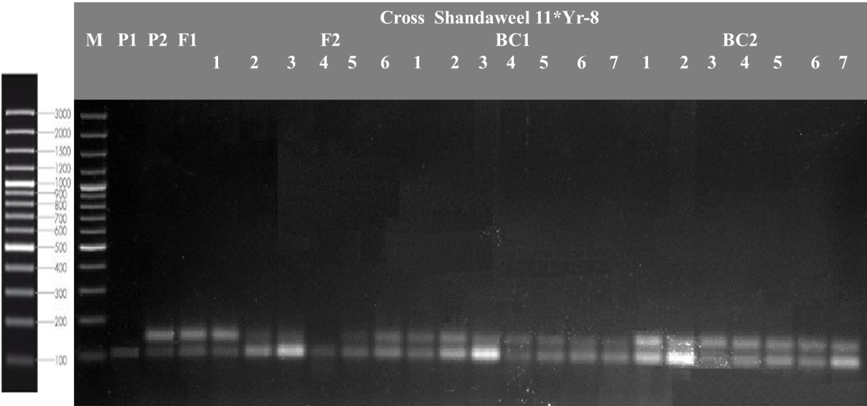
Figure 1: Amplification profile of SSR marker Xgwm157 marker linked to Yr8. The arrow showed the fragment which is associated with Yr8.

Likewise, a microsatellites marker barc8 linked to Yr15 was used to detect the presence of the Yr15 gene in current materials. (Figure 1)

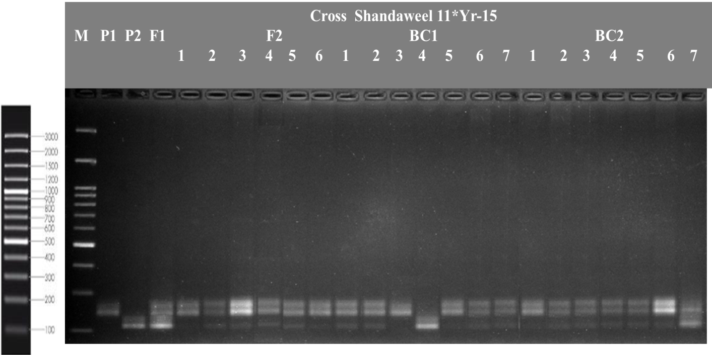
Figure 2: Amplification profile of SSR marker barc8 marker linked to Yr15. The arrow showed the fragment which is associated with Yr15.

The data in table 6 presents the polymorphic and monomorphic band distribution among the two wheat crosses. In the Shandaweel 1 × Yr8 cross, the 150 bp band was polymorphic, while the 105 bp band was monomorphic. In contrast, in the Shandaweel 1 × Yr15 cross, all bands (105 bp, 150 bp, and 180 bp) were polymorphic. The 105 bp band, which was shared between both crosses, remained monomorphic, indicating a conserved genetic locus that is potentially associated with yellow rust resistance.
A total of three bands were analyzed: 105 bp, 150 bp, and 180 bp. Among them, two bands (150 bp and 180 bp) were polymorphic, and one band (105 bp) was monomorphic.
Percentage of Polymorphism =
(Polymorphic bands/ total number of bands) x 100 = (2/3) x 100= 66.66%
Percentage of Monomorphism =
(Monomorphic Bands /Total Number of Bands ×100) = (1/3) x 100 = 33.33%

Table 6: polymorphism and monomorphic bands distribution among the two wheat crosses:
 |  |  |  |  | F₂ |  |  |  |  |  | Bc₁ |  |  |  |  |  |  | BC₂
cross Shandaweel 1x Yr 8 | MW | P1 | Yr8 | F1 | 1 | 2 | 3 | 4 | 5 | 6 | 1 | 2 | 3 | 4 | 5 | 6 | 7 | 1 | 2 | 3 | 4 | 5 | 6 | 7
cross Shandaweel 1x Yr 8 | 105 | 1 | 1 | 1 | 1 | 1 | 1 | 1 | 1 | 1 | 1 | 1 | 1 | 1 | 1 | 1 | 1 | 1 | 1 | 1 | 1 | 1 | 1 | 1
cross Shandaweel 1x Yr 8 | 150 | 0 | 1 | 1 | 1 | 0 | 0 | 0 | 1 | 1 | 1 | 1 | 0 | 1 | 1 | 1 | 1 | 1 | 1 | 1 | 1 | 1 | 1 | 1
cross Shandaweel 1x Yr 15 | MW | P1 | Yr15 | F1 | 1 | 2 | 3 | 4 | 5 | 6 | 1 | 2 | 3 | 4 | 5 | 6 | 7 | 1 | 2 | 3 | 4 | 5 | 6 | 7
cross Shandaweel 1x Yr 15 | 105 | 0 | 1 | 1 | 0 | 1 | 1 | 1 | 1 | 0 | 1 | 1 | 0 | 1 | 0 | 1 | 1 | 0 | 1 | 1 | 1 | 1 | 1 | 1
cross Shandaweel 1x Yr 15 | 150 | 1 | 0 | 1 | 0 | 1 | 1 | 1 | 1 | 1 | 1 | 1 | 1 | 0 | 1 | 1 | 1 | 1 | 1 | 1 | 1 | 1 | 1 | 1
cross Shandaweel 1x Yr 15 | 180 | 1 | 0 | 1 | 1 | 1 | 1 | 1 | 1 | 1 | 1 | 1 | 1 | 0 | 1 | 1 | 1 | 1 | 1 | 1 | 1 | 1 | 1 | 0

The SSR marker analysis revealed that 66.66% of the bands were polymorphic, demonstrating significant genetic diversity between the parents and their progeny. Conversely, 33.33% of the bands were monomorphic, indicating the presence of conserved regions essential for biological functions. This balance of polymorphism and monomorphism provides a strong foundation for genetic studies, as polymorphic markers help in identifying genetic diversity and inheritance patterns, while monomorphic markers may indicate essential or conserved traits.
Multivariate Heatmap Analysis
Multivariate clustering analysis is a powerful tool for distinguishing wheat genotypes based on both morphological characteristics and molecular data. This approach provides a solid foundation for selecting genotypes with favorable traits. By integrating field observations with molecular markers such as Yr8, the study underscores the advantages of combining phenotypic and genotypic methods to enhance the efficiency and precision of wheat breeding programs.

To investigate the relationships among six populations from two wheat crosses (Shandaweel 1 × Yr8 and Shandaweel 1 × Yr15), multivariate clustering heatmaps were employed. This technique facilitated the identification of clusters based on morphological and molecular data while also examining their interactions. A heatmap was generated using Euclidean distance and Ward’s linkage method, with the analysis conducted in R software, as shown in Figure 3. This visualization provided valuable insights into the genetic and phenotypic similarities and differences both within and between the populations.

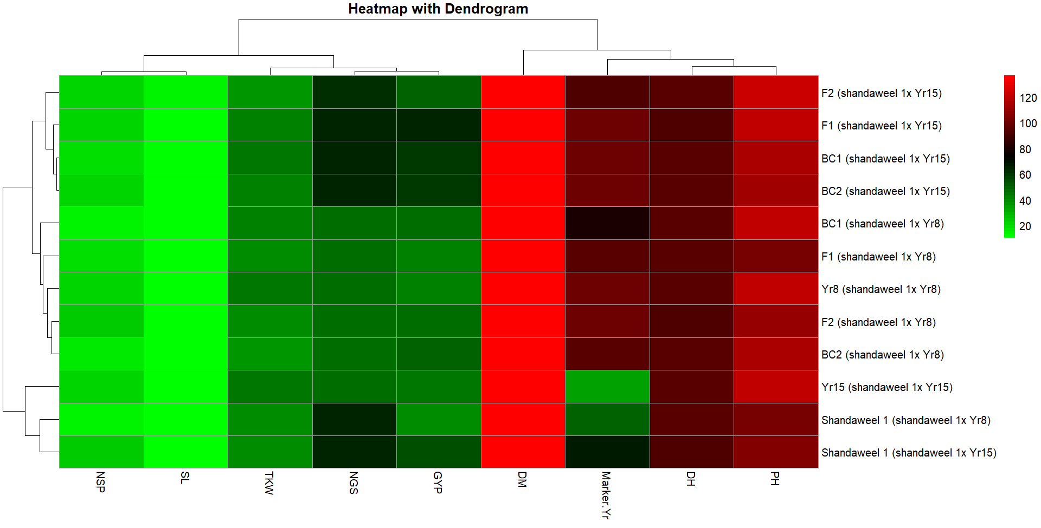
Figure 3. Multivariate heat map illustrating the genetic diversity of six populations of cross (Shandaweel 1 x Yr8 and Shandaweel 1 x Yr 15), based on one SSR marker and nine field traits using the module of a heatmap of ClustVis—an online tool for clustering and visualizing multivariate data. (Tauno Metsalu et al., 2015).

The rows represent the genotypes, including parents (Shandaweel 1, Yr8, and Yr 15), F₂, F₁, BC₁, and BC₂, derived from crosses "Shandaweel 1 × Yr15" and "Shandaweel 1 × Yr8," while the columns represent agronomic traits, including plant height (PH), days to heading (DH), marker Yr, days to maturity (DM), grain yield per plant (GYP), number of grains per spike (NGS), TKW (Thousand Kernel Weight), spike length (SL), and number of spikes per plant (NSP).
According to the heatmap data, the studied traits were distributed vertically into two clusters. The first cluster contains three groups; the first group contains plant height (PHT) and days to heading (DH), whereas each of the markers, Yr and days to maturity (DM), fell into a single group.
The second cluster includes traits in three groups. The first group contains grain yield per plant (GYP) and number of grains per spike (NGS), whereas 1000 kernel weight (TKW) fell into a single group. The third group contains spike length (SL) and number of spikes per plant (NSP).
The genotypes representing the six populations of the two crosses were distributed horizontally into three clusters. The first cluster contains 3 groups; each of F₂ and F₁ of the cross (Shandaweel 1 x Yr15) fell in a single group, while BC₁ and BC₂ fell in the same group. The second cluster contains 4 groups; each of F₁, BC₁ of the cross (Shandaweel 1 x Yr8), and genotype Yr 8 fell in a single group, while F₂ and BC₂ of the cross (Shandaweel 1 x Yr8) fell in the same group. The third cluster contains 2 groups: Yr15 in a single group, while genotypes Shandaweel 1 in the two crosses came in the second group, which is expected since they are the same parent.
The color gradients (green to red) in the heatmap provide valuable insights into the performance of various genetic structures across the studied traits.

According to the heatmap in Fig. 3, traits like days to maturity (DM), plant height (PH), and days to heading (DH) exhibit predominantly red shades across most genotypes. This indicates consistently high values and suggests that these traits are stable and less influenced by genetic diversity across the studied genotypes. Whereas traits such as spike length (SL), 1000 kernel weight (TKW), number of grains per spike (NGS), and number of spikes per plant (NSP) display a broader range of colors (green to red). This indicates significant variability among the genotypes, making these traits potential targets for trait improvement and selection in breeding programs.
For instance, TKW and NGS show both dark green and red shades, reflecting a range of performance across the genotypes.
The genotype Yr15 (Shandaweel 1 x Yr15) exhibits distinct performance patterns, showing a mix of green and red shades for Marker Yr and other traits. This highlights its potential in excelling for specific traits, which could indicate the presence of valuable alleles.
Similarly, BC₁ and F₁ in Cross 2 (Shandaweel 1 x Yr15) also display unique patterns for traits like SL and TKW, further emphasizing their potential as candidates for targeted improvement.
The data reveals that stable traits like PH, DH, and DM are consistently high across the genetics, while traits such as SL, TKW, and NSP exhibit greater variability. This variability offers significant opportunities for targeted selection and breeding efforts. Genotypes like Yr15, BC₁, and F₁ from Cross (Shandaweel 1 x Yr15) demonstrate unique trait performance, suggesting their potential for improving specific agronomic traits.
Biplots:
Biplots are used to show statistical results and give details about parameters under investigation. In previous studies, they were employed to display and show different kinds of data (Azza et al. 2021 and Zayed et al. 2022). Biplots allow information to be dispersed by allocating genotypes according to all traits being studied, whether they are molecular or morphological.

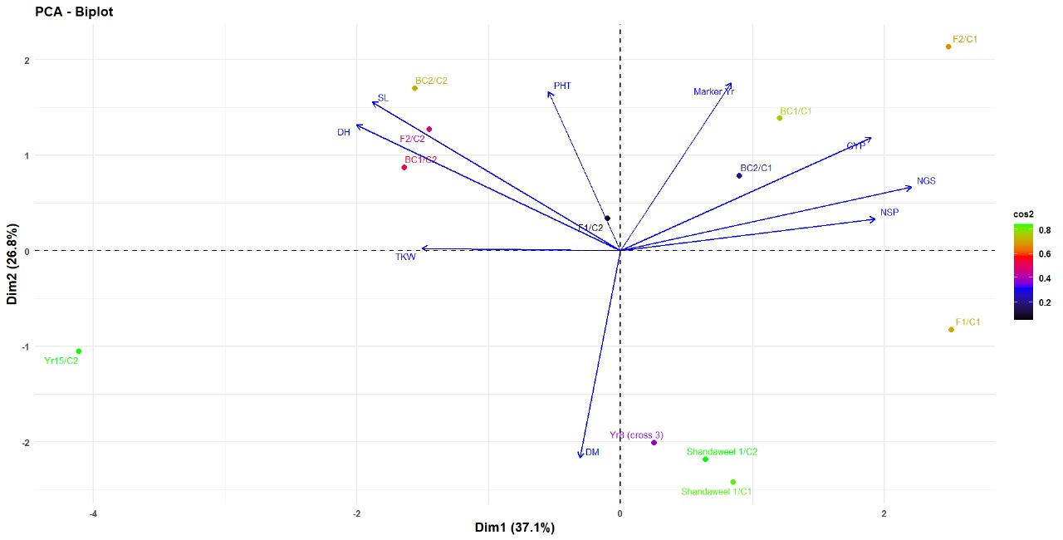
Figure 4. This PCA biplot illustrates the distribution of genotypes and traits along two principal components, Dim1 (37.1%) and Dim2 (26.8%), which together explain 63.9% of the total variation in the dataset.

Traits are represented as arrows, where the direction and length indicate their influence and correlation. Traits closer together have a strong positive correlation, while those pointing in opposite directions are negatively correlated.
PHT (plant height) and marker yr are positively correlated and extend towards the right, associating with genotypes BC₁ and BC₂ from the cross (Shandaweel 1 x yr15), which lie in the same direction.
While GYP (Grain Yield per Plant), NSP (Number of Spikes per Plant), and NGS (Number of Grains per Spike) are grouped closely, showing a strong correlation and pointing towards the right quadrant. These traits are associated with genotypes F₁ and BC₁ from the cross (Shandaweel 1 x Yr 8).
Traits such as SL (Spike Length) and DH (Days to Heading) exhibit a similar direction in the left upper quadrant, closely linked to genotypes F₂ and BC₁ from the cross (Shandaeel 1 x Yr 8).
Trait TKW (1000 Kernel Weight) points leftward, in contrast to GYP and NSP, suggesting it is negatively correlated with these yield traits. While DM (Days to Maturity) is oriented downward and far from other traits, suggesting it is independent or negatively correlated with yield-related traits.
The genotypes are distributed across the plot, indicating diversity in their performance.
The figure showed that F₁ and F₂ from the cross (Shandaweel 1 x Yr 8) are located in the top-right quadrant, associated with high GYP, NSP, and NGS values. While F₂ and BC₁ from the cross (Shandaweel 1 x Yr 15) cluster in the upper-left quadrant, aligning with SL and DH traits.
The parents of cross 2, Yr15 and Shandaweel 1, are positioned in the bottom-left quadrant, far from yield-related traits, indicating lower contributions to these parameters.
The clustering of genotypes and traits highlights important relationships; high-yield traits (GYP, NSP, NGS) are strongly aligned with certain genotypes like F₁ and BC₁ from the cross (Shandaweel 1 x Yr 8), making them potential candidate genotypes for yield improvement.
The biplot effectively differentiates genotypes, providing a clear guide for targeted selection and breeding strategies based on trait performance.
In conclusion, F₁ and BC₁ from cross (Shandaweel 1 x Yr8) and BC₁ from (Shandaweel 1 x Yr15) are the most promising genetic structures for improving high-yield traits, while genotypes like Yr15 and Shandaweel 1 can contribute to stable traits like PH, DH, and DM. These genetic structures should be targeted for further selection and breeding to enhance both yield and stability in future generations.
The analysis of the heatmap and biplot reveals that several genotypes are promising candidates for future breeding programs. Genotypes Yr15 and BC₁ from Cross (Shandaweel 1 x Yr 15) show unique performance, particularly in traits like spike length (SL) and kernel weight (TKW), suggesting that they may carry valuable alleles for these traits.
The genotypes from the cross (Shandaweel 1 x Yr8), including F₁, F₂, BC₁, and BC₂, exhibit strong correlations with yield-related traits such as grain yield per plant (GYP), number of grains per spike (NGS), and number of spikes per plant (NSP), making them ideal candidates for enhancing yield.
Meanwhile, Misr1, which forms a distinct group in the biplot, shows stability in traits like plant height (PHT), days to heading (DH), and days to maturity (DM), making it useful for stabilizing these traits in breeding programs.

Conclusion
Incorporating Yr monogenic lines into wheat breeding programs is a crucial approach to enhancing resistance to yellow rust (Pst). These lines contain resistance genes that specifically target various races of the rust pathogen. By integrating Yr lines into local or commercial wheat varieties, breeders can strengthen wheat's resilience against rapidly evolving strains of the disease. Crossbreeding with different Yr lines enables the development of wheat cultivars that can resist multiple races of yellow rust, minimizing the reliance on chemical fungicides and improving crop stability. Additionally, these resistance genes can be combined with other valuable traits, such as higher yield and improved grain quality, resulting in more robust wheat varieties suitable for a wide range of environmental conditions. The use of advanced genetic tools, such as SSR (Simple Sequence Repeat) markers, further aids in identifying and tracking these resistance genes, facilitating the selection of superior plants. This combination of disease resistance and desirable agronomic traits has the potential to significantly boost wheat productivity while reducing the impact of yellow rust on the yield.

References

Abd El- Rady, A. G. (2018), Genetic analysis of some agronomic traits in two bread wheat crosses under heat stress conditions, Journal of Plant Production, 9(1): 21-28.
Abd El-Hamid E. A. M, and Zeinab E. Ghareeb (2018). Generation mean analysis for estimating some genetic parameters in four bread wheat crosses.The Seventh Field Crop Conference 8-9 December, ARC, Egypt. 12-25.
Abd El-Rahman, Magda E. (2013). Estimation of some genetic parameters through generation mean analysis in three bread wheat crosses. Alex. J. Agric. Res. 58(3):183‐195.
Abdalla, Ahmed, Till Stellmacher, and Mathias Becker. )2023(. Trends and Prospects of Change in Wheat Self-Sufficiency in Egypt. Agriculture 13, no. 1: 7.https://doi.org/10.3390/agriculture13010007
Afzal, S. N., M. I. Haque, M. S. Ahmedani, S. Bashir and A. R. Rattu. (2007) Assessment of yield losses caused by Puccinia striiformis triggering stripe rust in the most common wheat varieties. Pakistan Journal of Botany, 39: 2127-34.
Ahmed B. H. (2021). Estimates of genetic parameters using six populations in two bread wheat crosses, Archives of agriculture science journal, 4 (1):330-341
Amin, I. A. (2013) Genetic behavior of some agronomic traits in two durum wheat crosses under heat stress, Alexandria Journal of Agricultural Science,58 (1): 53–66.
Ashmawy, M. A. and K. E. Ragab. (2016) Grain yield of some wheat genotypes to stripe rust in Egypt. Menoufia Journal of Plant Protection, 1: 9-18.
El-Aref, Kh. A. O., Tammam A. M., Ibrahim, M. M. and Koubisy, Y. S. I. (2011). Generation mean analysis in bread wheat under drought conditions. Egyptian Journal of Applied Sciences, 26 (2):187–208.
El-Aref, Kh. A. O., Tammam A. M., Ibrahim, M. M. and Koubisy, Y. S. I. (2011). Generation mean analysis in bread wheat under drought conditions, Egyptian Journal of Applied Sciences, 26(2):187–208.
El-Gammaal, A. A. and Yahya, A. I. (2018). Genetic variability and heterosis in F1 and F2 generations of diallel crosses among seven Wheat genotypes, Journal of Plant Production, 9 (12): 1075–
Elmassry, E. L. and El-Nahas, M. M. (2018), Genetic behavior of some agronomic characters in three Bread Wheat crosses under different environmental conditions, Alexandria Journal of Agricultural Science, 63 (5): 313–325.
Elmassry, E. L. and El-Nahas, M. M. (2018), Genetic behavior of some agronomic characters in three Bread Wheat crosses under different environmental conditions, Alexandria Journal of Agricultural Science, 63 (5): 313–325.
Feng, J., Wang, M., See, D. R., Chao, S., Zheng, Y., and Chen, X. (2018). Characterization of novel gene Yr79 and four additional quantitative trait loci for all-stage and high-temperature adult-plant resistance to stripe rust in spring wheat PI 182103. Phytopathology 108, 737–747. doi: 10.1094/PHYTO-11-17-0375-R
Gamble, E.E. (1962). Gene effects in corn (Zea mays L.). 1- Separation and relative importance of gene effects for yield. Can. J. of Plant Sci., 42: 339-348.
Hamam ,K.H. (2014). Genetic analysis of agronomic parameters in bread wheat using six parameters model under heat stress. Egypt. J. Agron, 36(1)1-18.
Hamam, K.A. (2013). Estimation of genetic parameters using five populations model in three bread wheat crosses under normal irrigation and drought stress. J. Plant bread. 17 :(2),63-79.
Hayman, B.I. and K. Mather (1955). The description of gene interaction in continuous variation. Biometrics, 10: 69-82
Johnson, V.A., K.G. Biever, A. Haunhold, and J.W. Schmidt (1955). Inheritance of plant height, yield of grain and other plant and seed characteristics in a cross of hard red winter wheat (Triticum aestivum L.). Crop. Sci., 6: 336-338.
Kalendar, R., Boronnikova, S. and Seppänen, M. (2021). Isolation and Purification of DNA from Complicated Biological Samples. In: Besse, P. (eds) Molecular Plant Taxonomy. Methods in Molecular Biology, vol 2222. Humana, New York, NY. https://doi.org/10.1007/978-1-0716-0997-2_3
Kearsey, M.J. and Pooni, H.S. (1996) the Genetical Analysis of Quantitative Traits. Chapman and Hall, London. http://dx.doi.org/10.1007/978-1-4899-4441-2
Khalid A, A, Hameed, MF, Tahir. (2023). Wheat quality: A review on chemical composition, nutritional attributes, grain anatomy, types, classification, and function of seed storage proteins in bread making quality. Front Nutr. Feb 24;10:1053196. doi: 10.3389/fnut.2023.1053196. PMID: 36908903; PMCID: PMC9998918.
Khattab, S. A. M., Esmail, R. M. and Abd Al-Ansary, E. M. F. (2010), Genetical analysis of some quantitative traits in bread wheat (Triticum aestivum L), New York Science Journal, 3 (11):152–157.
Koumber, R. M. and A. A. El-Gammaal (2012). Inheritance and gene action for yield and its attributes in three bread wheat crosses (Triticum aestivum L.). World Journal of Agricultural Sciences 8 (2): 156-162.
Kumar, A., A. Razdan., V, Sharma., N, Kumar., and D, Kumar. (2018), Study of heterosis and inbreeding depression for economic and biochemical traits in bread Wheat (Triticum aestivum L.), Journal of Pharmacognosy and Photochemistry, 7 (4): 558–564.
Kuobisy, Y. S. I. (2011), Generation mean analysis in bread wheat under drought conditions, M.Sc. Thesis, Faculty of Agriculture, Al-Azhar University, Assuit, Egypt.
Martínez-Moreno, F., Giraldo, P., Nieto, C., and Ruiz, M. (2022). Resistance to leaf and yellow rust in a collection of Spanish bread wheat landraces and association with ecogeographical variables. Agronomy 12, 187. doi: 10.3390/agronomy12010187
Mather, K. (1949). Biometrical Genetics. 1st Edition, Metheum and Co., London, 162 pp.
Mohamed A. I. K. (2013). Genetic system controlling the yield and its components in the three bread wheat (Triticum aestivum,L.) crosses. Egypt. J. Agric. Res., 91(2), 641.
Mohan, N., Jha, S. K., Mallick, N., Niranjana, M., Raghunandhan, R. K., Singh, A., Saharan, M. S., Thribhuvan, R., Singh, S. K., Dhanya, V. and Vinod, V. (2024). Marker-assisted improvement of stripe rust resistance in hybrid wheat. Indian Journal of Genetics and Plant Breeding, 84(04), 574–578. https://doi.org/10.31742/ISGPB.84.4.7
Mousaa, A.M. (2010). Estimation of epistasis, additive and dominance variation in certain bread wheat (Triticum aestivum L.) crosses. J. plant prod., Mansoura Univ, (12): 1707-1719
Nsabiyera, V., Bariana, H. S., Qureshi, N., Wong, D., Hayden, M. J., and Bansal, U. K. (2018). Characterisation and mapping of adult plant stripe rust resistance in wheat accession Aus27284. Theor. Appl. Genet. 131, 1459–1467. doi: 10.1007/ s00122-018-3090-x
Omara, R. I., Shahin, A. A., Ahmed, S. M., Mostafa, Y. S., Alamri, S. A., Hashem, M. and Elsharkawy, M. M. (2021). Wheat resistance to stripe and leaf rusts conferred by introgression of slow rusting resistance genes. Journal of Fungi, 7(8), 622. https://doi.org/10.3390/jof7080622
Peter, F.C. and K.J. Frey (1966). Genotypic correlation dominance and heritability of quantitative characters in oats Crop Sci., 6: 259-262.
Raikwar, RS., Anil Mishra and KC Shukla (2024) Estimation of genetic components for yield and quality characters in five diverse wheat (Triticum aestivum L.) crosses by six parameter model., International Journal of Advanced Biochemistry Research ; 8(4): 443-447
Saeed, S., Khan, N. U., Khalil, I. H., Ali, S., and Afridi, K. (2024). Heterotic effects and inbreeding depression in F1 and F2 populations of wheat. Pak. J. Bot., 56(3): 1001-1013. DOI: http://dx.doi.org/10.30848/PJB2024-3(15).
Sari, D., Sari, H., Ikten, C., and Toker, C. (2023). Genome-wide discovery of di-nucleotide SSR markers based on whole genome re-sequencing data of Cicer arietinum L. and Cicer reticulatum Ladiz. Scientific reports, 13(1), 10351. https://doi.org/10.1038/s41598-023-37268-w
Shahin AA, Omara RI, Omar HA, El-Din HS, Sehsah MD, Essa T, Zayton MA, and HS. Omar. (2024) Evaluation of effectiveness resistance genes in wheat genotypes using marker-assisted selection for stripe rust resistance breeding. BMC Plant Biol. 24(1):785. doi: 10.1186/s12870-024-05470-1. PMID: 39160472; PMCID: PMC11334449.
Sharma, S. N., R. S. Sain and R. K. Sharma (2003). The genetic control of flag leaf length in normal and late sown durum wheat. The Journal of Agricultural Science, 141: 323-331.
Tauno Metsalu and Jaak Vilo (2015). ClustVis: a web tool for visualizing clustering of multivariate data using Principal Component Analysis and heatmap, Nucleic Acids Research, 43, (W1), W566–W570, https://doi.org/10.1093/nar/gkv468
USDA-grain: world markets and trade-2024, page 23
Yassin M.M.M. and Zeinab E. Ghareeb (2019). Genetic behavior of some economic characters in three wheat crosses., J. Plant Breed. 23(7):1511– 1523
Zaazaa, E. I., Hagerand, M. A. and E. F. El- Hashash (2012).Genetical analysis of some quantitative traits in wheat using six parameters genetic model, American-Eurasian Journal of Agricultural & Environmental Sciences, 12( 4): 456–462.
Zhang, M., Saimi, A., Liu, Q., Ma, Z., and Chen, J. (2023). The Detection of Yr Genes in Xinjiang Wheat Cultivars Using Different Molecular Markers. International Journal of Molecular Sciences, 24(17), 13372. https://doi.org/10.3390/ijms241713372

